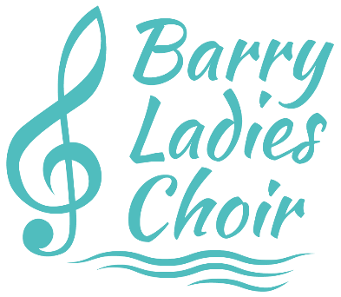
Barry Ladies Choir – Privacy notice

What is this guide for?
Whenever we need to collect any of your data, we will let you at that point why we need to do so and what it will be used for, but this guide provides a useful overview of all of those situations and provides more detail on how we keep your data secure and up to date, how long we might hold it for, and what your rights are in relation to it.
Barry Ladies Choir is committed to protecting your personal data and will use any personal or sensitive data we collect from you in line with the General Data Protection Regulations (GDPR).
Who’s responsible for data the group collects?
Barry Ladies Choir is a Data Controller under the GDPR. Barry Ladies Choir’s Data Protection Officer is the Chair who can be contacted at barryladieschoir@gmail.com.

What data do we collect and what do we use it for?
Barry Ladies Choir collects data from individuals to help us plan, organise and run the day-to-day operations of the group (e.g. co-ordinating rehearsals or collecting subscription payments) and to promote and market the group’s activities (e.g. marketing mailing lists and photography/video capture).
Members: for administering membership
When you join Barry Ladies Choir as a member, or during your membership with us, we may need to collect some of the following information on you:

• Name
• Email address
• Phone number
• Address
• Emergency contact details
• Medical information
• Photos/video footage
This data will be used by committee members to manage your membership with Barry Ladies Choir and to organise and run our activities.
If you give us your consent to do so, we may also use your contact details to send you marketing/promotional communications from the group.
Any marketing/promotional communication we send you will include a clear option to withdraw your consent (e.g. to ‘opt out’ of future emails) and you can also withdraw consent at any point by contacting the Data Protection Officer – the Chair
Event attendees: for processing and managing tickets for events
Where our events are ticketed, we need to collect data on the person booking (name and email) in order to allow you access to the event and to send you a confirmation of your reservation/purchase. This data will only be used for administering your access to the event/s for which you have booked and will not be used to send you marketing/promotional messages from the group unless you have also provided your consent to receive these (see below).
Employees and contractors: for administration and legal/regulatory purposes
We may need (for administration or for legal/regulatory reasons) to collect personal or sensitive data on employees or contractors of the group. Where this is the case, we will explain what this is for at the point of collection.
Website visitors: for running and improving our website
We use cookie technology when a person visits our website to collect and analyse anonymised data on how many people have visited, what pages they have looked at and other statistical information. We also use cookies to allow members to log in and out in order to view our members-only section.
We use a pop-up banner to let users know about this on their first visit, and they can at any time disable cookies in their browser if they do not wish their (anonymised) data to be tracked.
You can find out more about cookies at http://www.allaboutcookies.org/

Do we share your data with anyone else?
We will never pass your details on to third parties for marketing purposes.

How can you update your data?
You can contact us at any time at barryladieschoir@gmail.com to update or correct the data we hold on you or write to the Chair.

How long we will hold your data?
The Barry Ladies Choir data retention policy is to review all data held on individuals at least every two years and remove data where we no longer have a legitimate reason to keep it.
Where you have withdrawn your consent for us to use your data for a particular purpose (e.g. unsubscribed from a mailing list) we may retain some of your data for up to two years in order to preserve a record of your consent having been withdrawn.
What rights do you have?
Under the GDPR, you have the following rights over your data and its use:

• The right to be informed about what data we are collecting on you and how we will use it
• The right of access - you can ask to see the data we hold on you
• The right to rectification - you can ask that we update or correct your data
• The right to object - you can ask that we stop using your data for a particular purpose
• The right to erasure - you can ask us to delete the data we hold on you
• The right to restrict processing - you can ask that we temporarily stop using your data while the reason for its use or its accuracy are investigated
• Though unlikely to apply to the data we hold and process on you, you also have rights related to portability and automated decision making (including profiling)

All requests related to your rights should be made to the Data Protection Officer at barryladieschoir@gmail.com. We will respond within one month.

You can find out more about your rights on the Information Commission’s Office website
What will we do if anything changes?
If we make changes to our privacy statements or processes, we will post the changes here. Where the changes are significant, we may also choose to email individuals affected with the new details. Where required by law, will we ask for your consent to continue processing your data after these changes are made.

